# CS 255 System Design Document Template

Keith Ellison

This template lays out all the different sections that you need to complete for Project Two. Each section has guidance to prompt your thinking. You will need to continually reference the interview transcript as you work to make sure that you are addressing your client’s needs. There is no required length for the final document. Instead the goal is to complete each section based on what your client’s needs are. Remove this note when you are finished, and replace all bracketed text with the relevant information.

## UML Diagrams

### UML Use Case Diagram

### UML Activity Diagrams

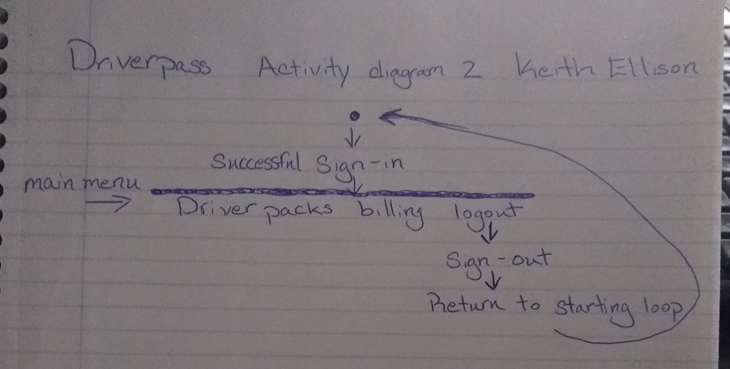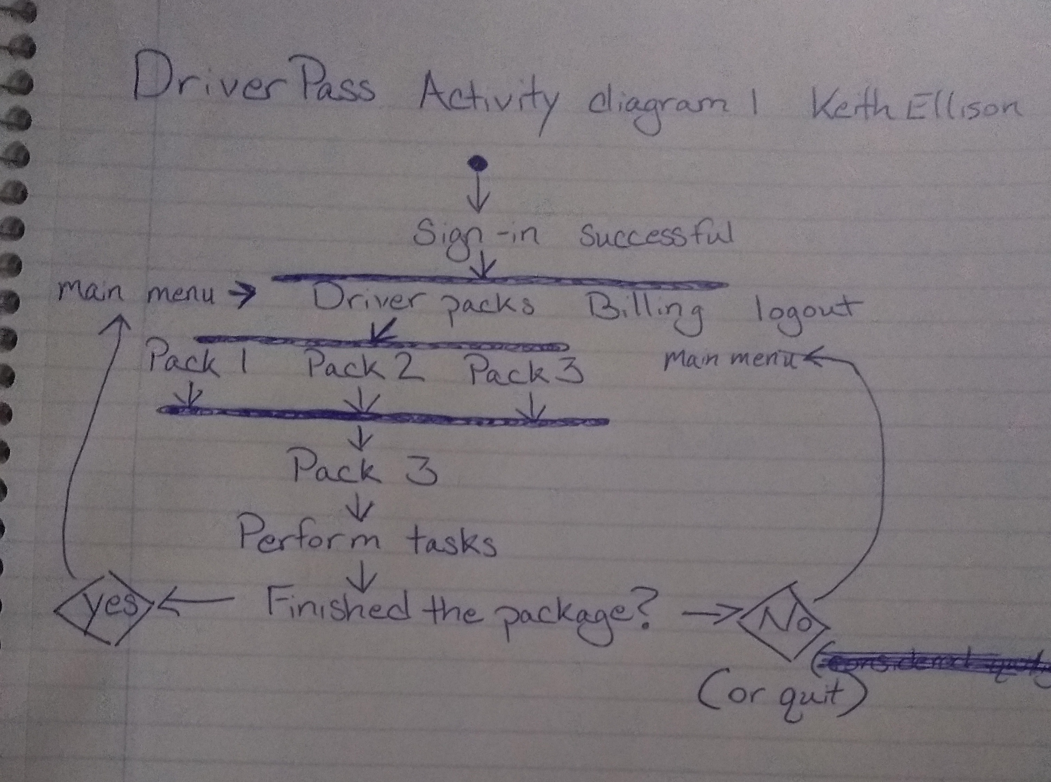

### UML Sequence Diagram

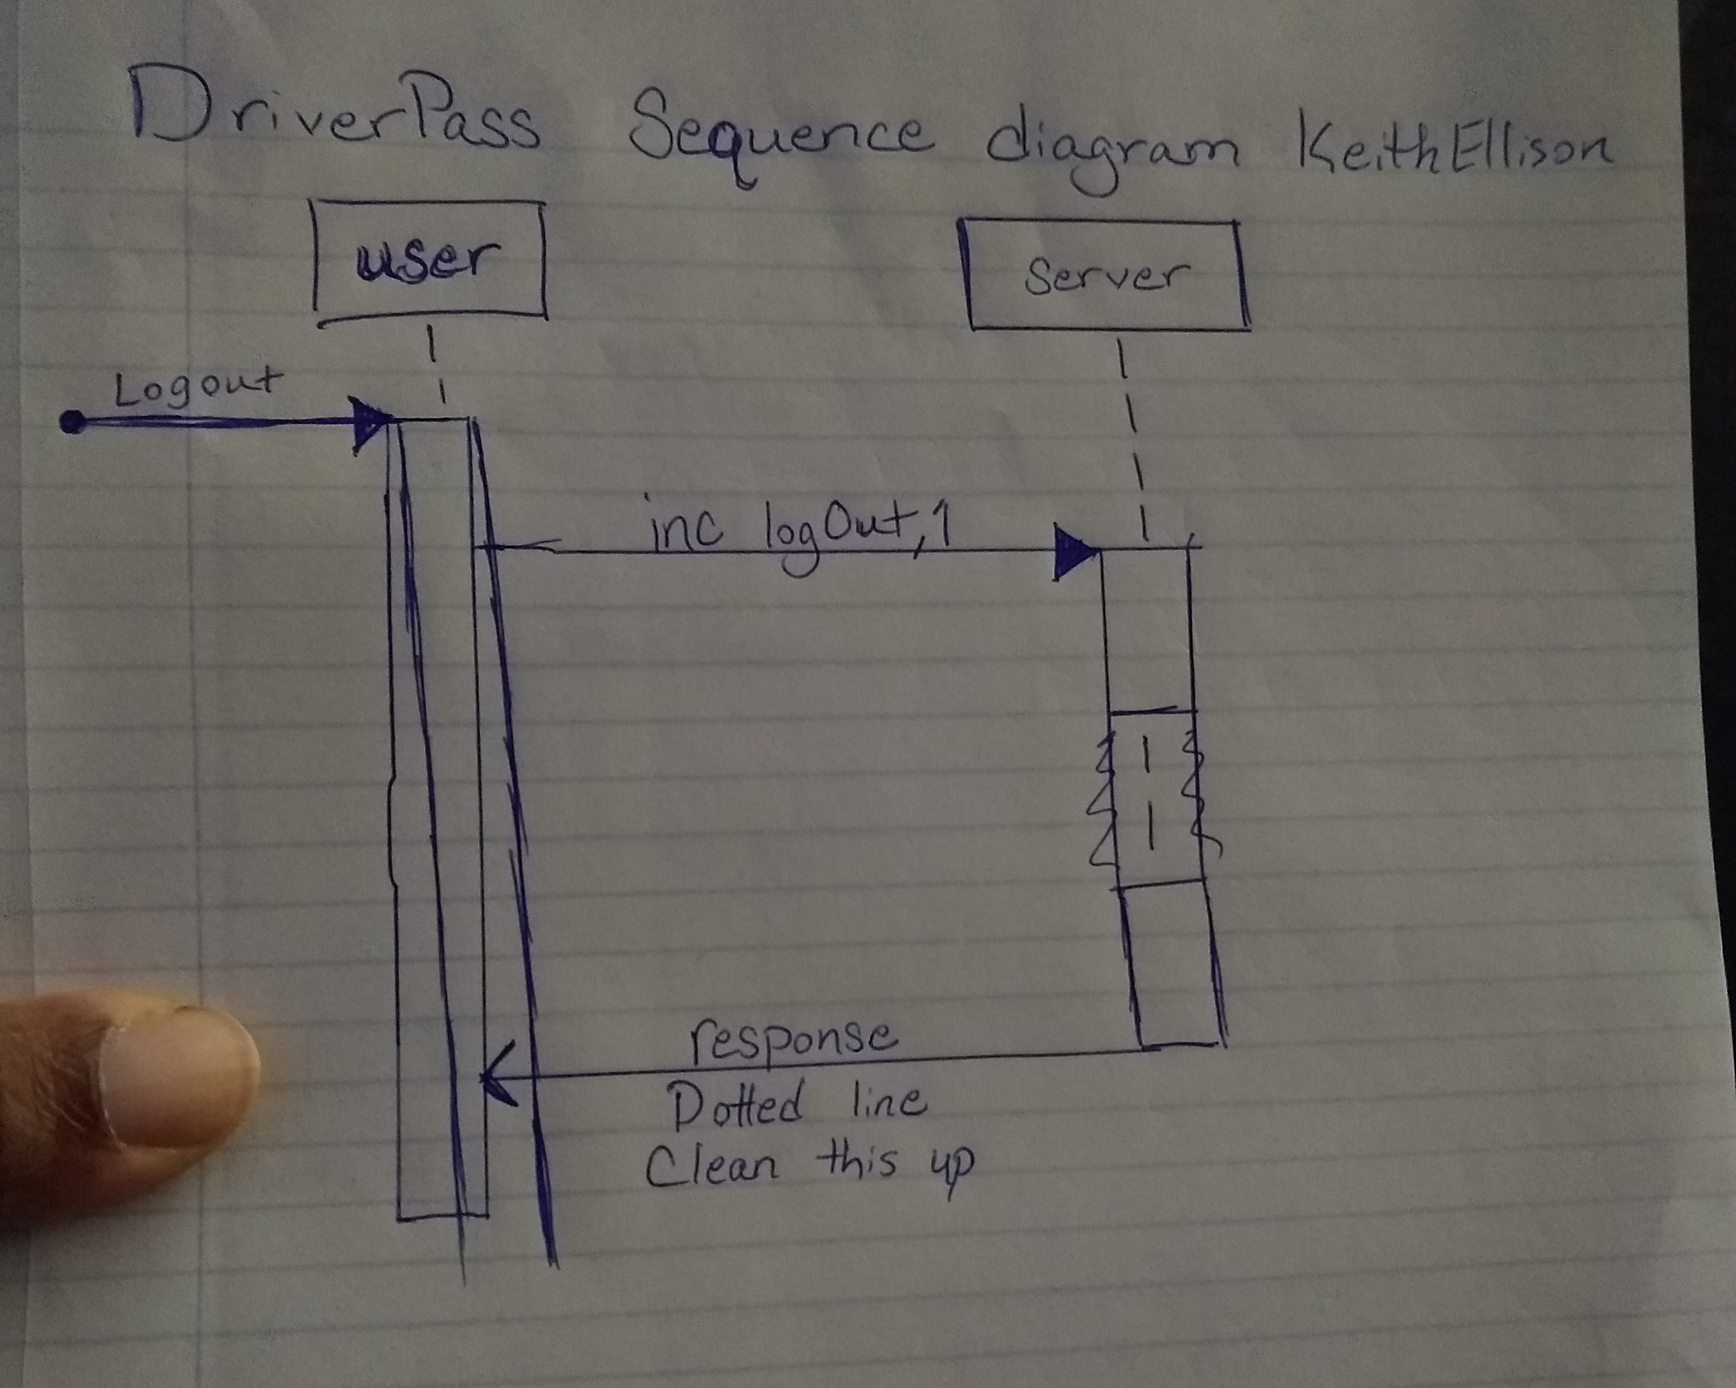

### UML Class Diagram

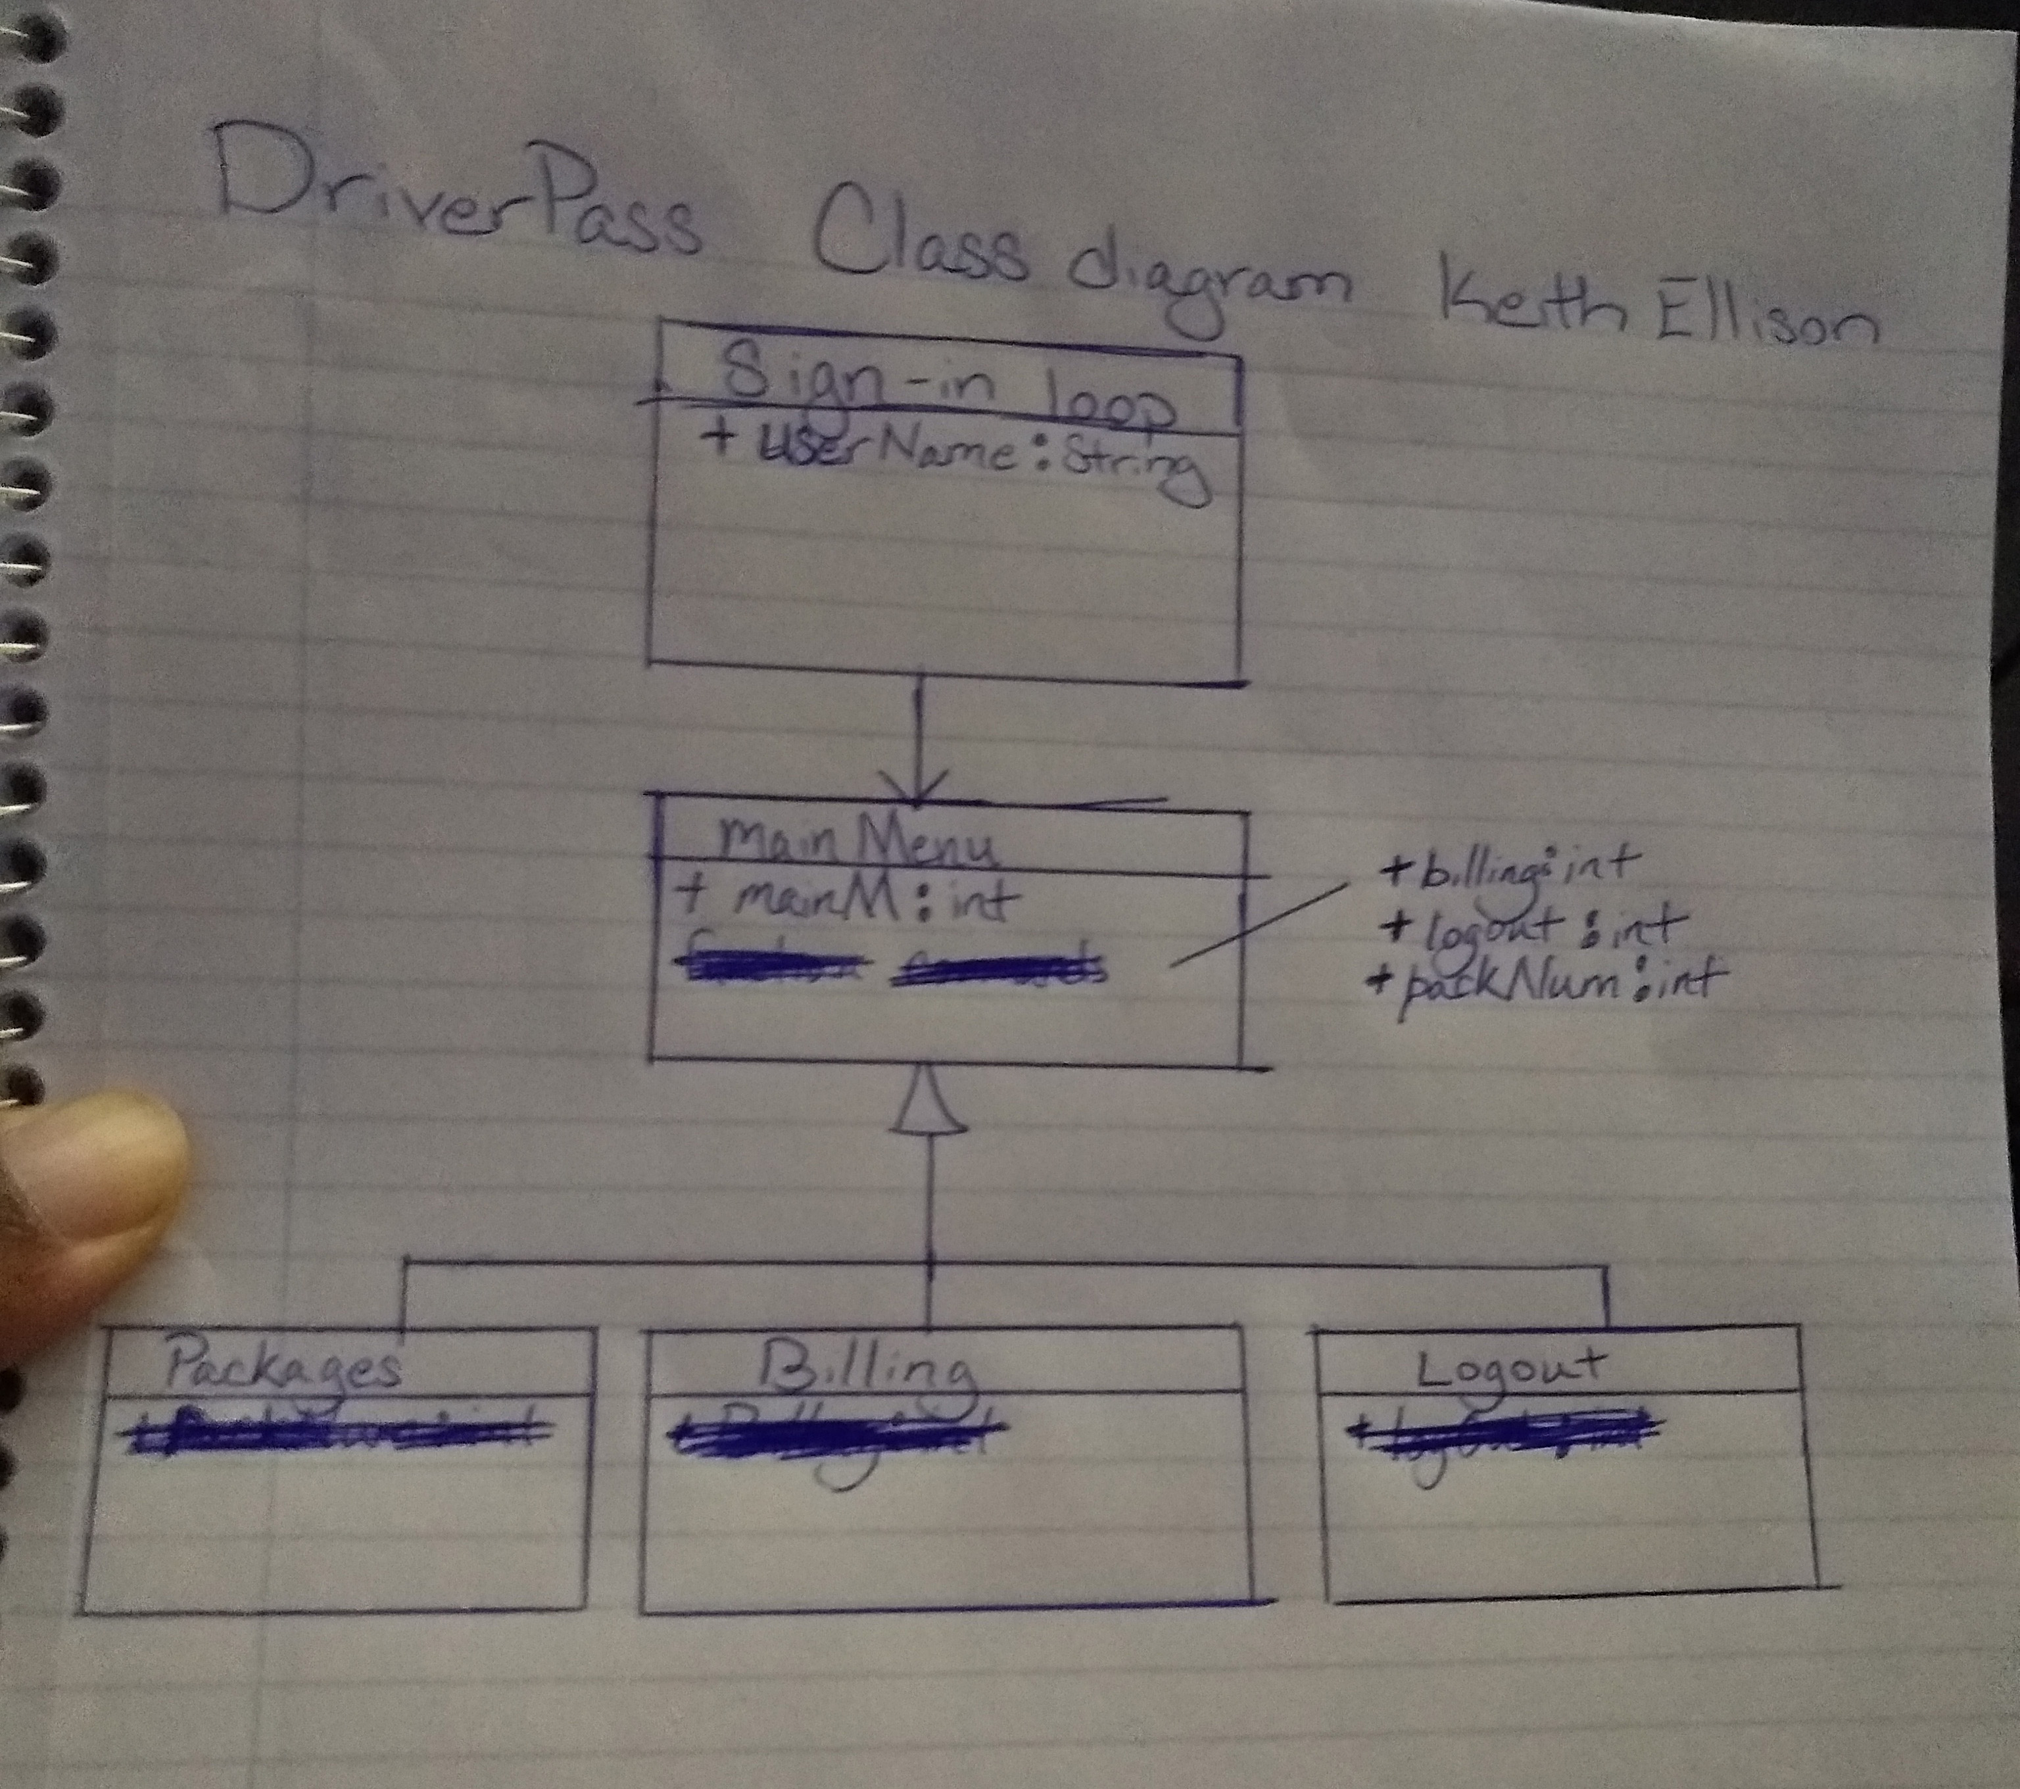

## Technical Requirements

*Intended to be as lightweight as possible, my system is built around it’s two program loops. The first one for entering your profile information and signing in, and the second for the program itself, once you’ve connected to the DriverPass server. Not knowing what sort of graphics if any, that are desired, this configuration should run on anything with a screen, keyboard and the ability to connect to the internet. This should be easy for DriverPass to implement on their end as it would be a very simple app to run and maintain. Once made I’m made aware of their format, I can account for the file type of the DriverPass exams the students will take. The external service CCBill can be used for online payments, unless they have their own ideas. Finally, a basic service configuration of whatever their budget will allow could be built to run their side of all this.*